**GIT Merge Conflicts:**

- Merge conflicts generally arise when more than one contributor have changed the same lines in a file.

- Or , if one has deleted the file while another was modifying it.

- Git will mark the file as being conflicted and halt the merging process.

Types of merge conflicts:

- Git fails to start the merge :

. Happens due to pending local changes.

. Working dir needs to be stabilize using git stash, git checkout and git commit commands.

. error: Entry '<filename>' not up-to-date . Cannot merge (Changes in working Directory)

- Git fails during the merge:

. Happens due to conflict between current local branch and branch being merged.

. This indicates a conflict of another dev code.

. Git will leave things for you to resolve manually the conflicted files.

. error: Entry '<filename>' would be overwritten by merge . Cannot merge (Changes in working Directory)

Conflict Dividers:

<<<<<<<<<< HEAD

content exists in current branch

=============== : Center

content exists in merging branch

>>>>>>>>>> master

**GIT Commands that can help resolve merge conflicts:**

- git status

- git log --merge

- git diff

- git checkout

- git reset --mixed

- git merge --abort

- git reset

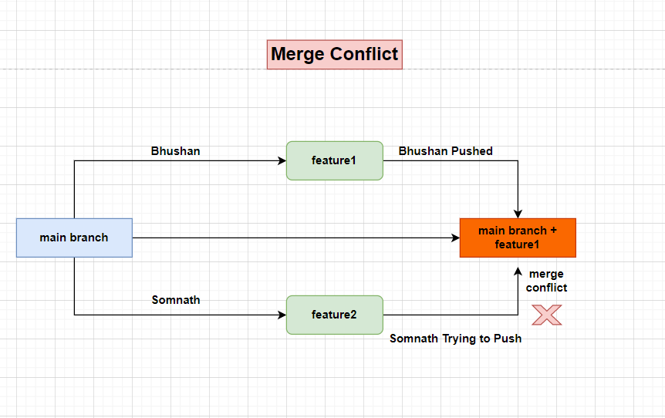

a) file1.txt and file2.txt is created and committed from master branch.

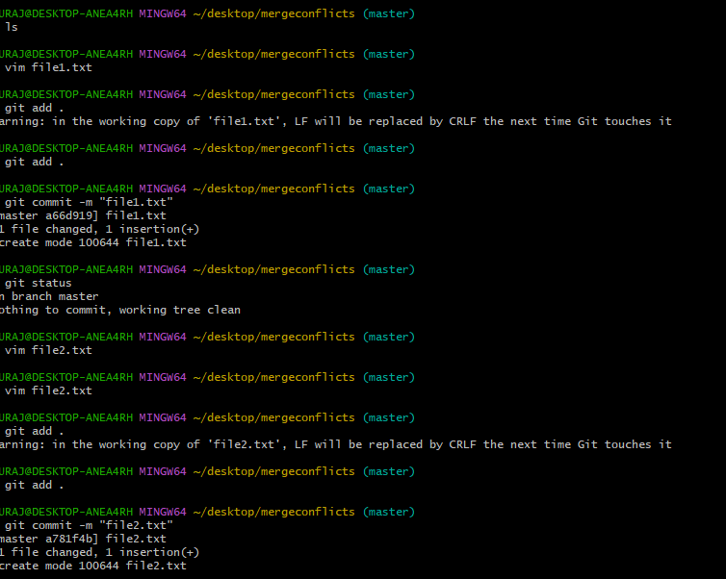

b) Created two branches branch1 and branch2 from master branch after that switched to branch1 and file1.txt is edited.

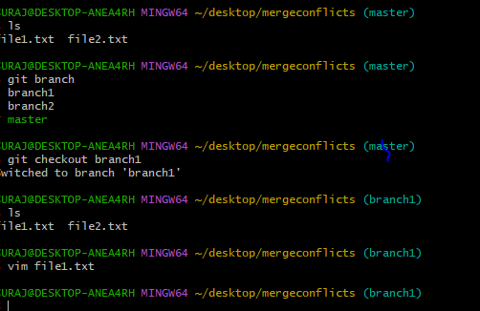

c) file1.txt is also committed from branch1.

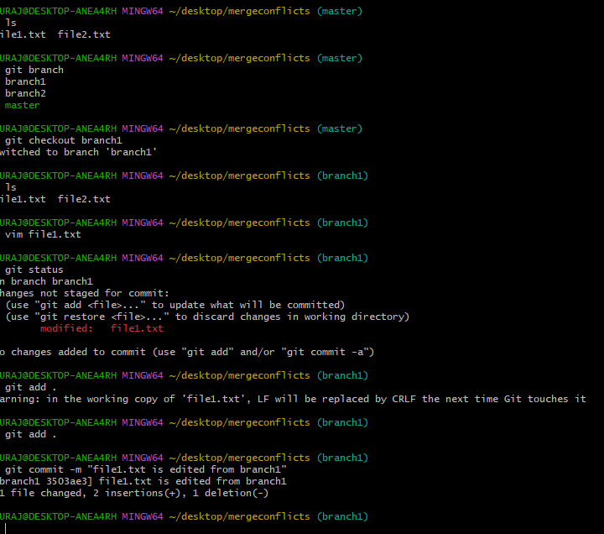

d)Switched to branch2 and edited file1.txt.

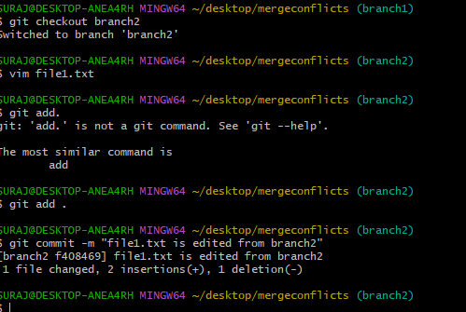

e) switched to branch2 committed file1.txt and then switched to master branch and executed git merge branch1.file1.txt is merged from branch1 to main branch.

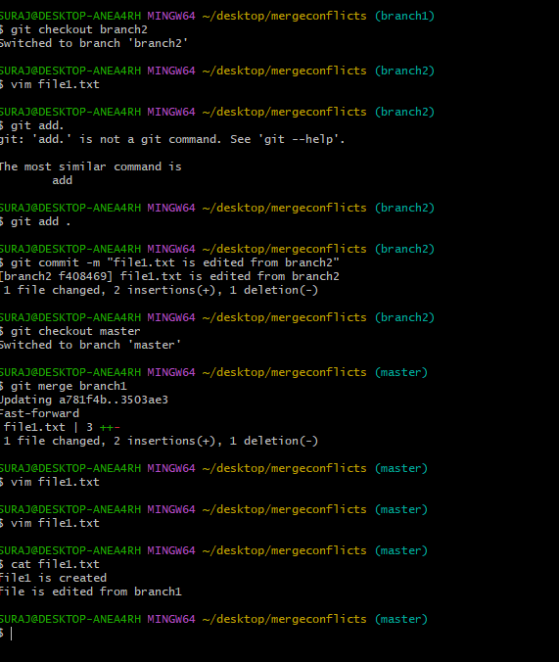

f) Branch2 also try to merged.

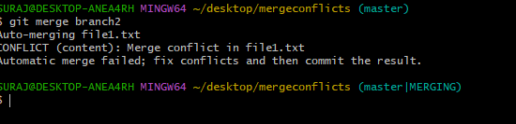

g) From Branch2 file1.txt edited file is not merged to master branch. See the file Merge conflicts is created.

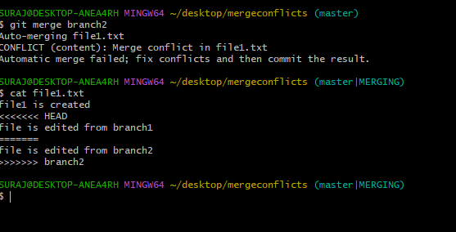

h)using mergetool fixed merge conflict after that merged both branch1 and branch2 proper into master branch.

